Hospital Staffing Analysis
The Scuba-Diving Deep-Dive Analysis Model

Pipeline: Cleaned Dataset → Python (Pandas/NumPy/Matplotlib) → MySQL → Power BI
Documentation of the Python and MySQL Analysis Phases

Contents
- 1. Business Problem & Methodology
- 2. The Datasets
- 3. Data Cleaning & Preparation
- 4. Building the Master Table
- 5. Dive 1 (WHERE) — Business Question 1: Understaffed Departments
- 6. Dive 2 (WHO) — Business Question 2: Overtime Accumulation
- 7. Dive 3 (WHEN) — Business Question 3: Absenteeism
- 8. Dive 4 (HOW MUCH) — Business Question 4: Patient Workload
- 9. Business Question 5: Shift Type Comparison
- 10. Business Question 6: Overtime Cost per Department
- 11. Business Question 7: Contract/Part-Time Reliance
- 12. Dive 5-7 — Root Cause Analysis
- 13. Dive 8 — Impact Assessment
- 14. Storyboard Narrative & Recommendations
- 15. Anticipated Questions & Answers (Viva Prep)
- 16. SQL Phase — MySQL Verification

1. Business Problem & Methodology
The hospital's leadership suspects that staffing levels, overtime, and absenteeism are creating operational strain in certain departments, but does not know precisely where the problem is worst, why it is happening, or what is actually driving it. The goal of this analysis is not to repeat numbers the client already has access to, but to investigate the data deeply enough to explain the mechanisms behind the numbers — i.e. find the root cause, not just the symptom.

1.1 The Scuba-Diving Analysis Model
The analysis follows a structured, progressively deeper methodology, treating the investigation like a scuba dive: start at the surface (what is happening), descend through layers of description (where/who/when/how much), then into deeper analytical layers (relationships, patterns, root cause, impact), before surfacing again to communicate findings.
- Surface Level — What is happening? (initial description of the problem)
- Dive 1 — WHERE? (Department / Shift / Location)
- Dive 2 — WHO? (Role / Staff / Contract Type)
- Dive 3 — WHEN? (Date / Month / Weekday / Shift)
- Dive 4 — HOW MUCH? (Staffing / Workload / Absence / Overtime)
- Dive 5 — WHAT ELSE? (Relationships between indicators)
- Dive 6 — WHY? (Patterns that may explain the issue)
- Dive 7 — ROOT CAUSE? (What combination of factors is associated with the problem)
- Dive 8 — IMPACT (Cost / workload / staffing / operational risk)
- Come back to Surface → Storyboard → Insight + Recommendation

1.2 Guiding Principle
Key principle: The client already knows the surface-level facts about their own data. The value of this analysis is in the 'why' layer — every claim about a cause is tested statistically (correlation, group comparison) rather than simply asserted from eyeballing a chart. Findings that don't hold up under testing are reported as ruled out, not hidden.

1.3 Tools & Pipeline
Python (pandas, NumPy, matplotlib) is used for data cleaning, merging, exploratory analysis, statistical testing, and chart generation. MySQL is used next to structure the cleaned/merged data relationally for querying. Power BI is used last to build the interactive, client-facing storyboard. This document covers the Python phase in full detail.

2. The Datasets
Five cleaned CSV files were provided, forming a star-schema-like structure: one fact table (shifts) and four dimension/reference tables.
File | Rows | Key Columns | Role
shifts.csv | 200 | shift_id, staff_id, dept_id, date_id, shift_type, hours_worked, overtime_hrs, patients_attended, absent_flag | Fact table — one row per shift worked
staff.csv | 40 | staff_id, staff_name, role, experience_yrs, contract_type, hourly_rate | WHO dimension
department.csv | 10 | dept_id, dept_name, required_staff_per_shift, criticality | WHERE dimension
dates.csv | 365 | date_id, full_date, day_of_week, month, quarter, year, is_weekend | WHEN dimension
role_benchmark.csv | 3 | role, max_patients_per_shift, standard_shift_hrs, overtime_threshold_hrs | Benchmark/reference values

3. Data Cleaning & Preparation
Before any analysis, each of the five tables was checked individually for null values, duplicate rows, and correct data types.
import pandas as pd
import numpy as np
import matplotlib.pyplot as plt
shifts = pd.read_csv('shifts.csv')
staff = pd.read_csv('staff.csv')
department = pd.read_csv('department.csv')
dates = pd.read_csv('dates.csv')
benchmark = pd.read_csv('role_benchmark.csv')
print("shifts:", shifts.shape) # 200 rows, 10 columns
print("staff:", staff.shape) # 40 rows, 6 columns
print("department:", department.shape) # 10 rows
print("dates:", dates.shape) # 365 rows, 7 columns
print("role_benchmark:", benchmark.shape) # 3 rows
For every table: .head(), .info(), .describe(include='all'), .isnull().sum(), and .duplicated().sum() were run to confirm there were no missing values or duplicate rows left in the cleaned files.

3.1 Data Type Correction
Date columns loaded as generic 'object' (text) type by default. This was corrected to a proper datetime type so date-based operations (sorting, filtering, extracting weekday/month) work correctly:
print(dates['full_date'].dtype) # object (text) — before fix
dates['full_date'] = pd.to_datetime(dates['full_date'], format='%d-%m-%Y')
print(dates['full_date'].dtype) # datetime64[ns] — after fix

3.2 Join-Key Integrity Check
Before merging any tables, it is essential to confirm every foreign key in the fact table (shifts.csv) actually exists in the corresponding dimension table. An unmatched key would silently create missing data during a merge.
missing_dept = shifts[~shifts["dept_id"].isin(department["dept_id"])]
missing_staff = shifts[~shifts["staff_id"].isin(staff["staff_id"])]
missing_date = shifts[~shifts["date_id"].isin(dates["date_id"])]
print("Shifts with unknown dept_id:", len(missing_dept)) # 0
print("Shifts with unknown staff_id:", len(missing_staff)) # 0
print("Shifts with unknown date_id:", len(missing_date)) # 0
print(staff["role"].unique()) # ['Nurse' 'Doctor' 'Technician']
print(benchmark["role"].unique()) # ['Nurse' 'Doctor' 'Technician']
Result: All three orphan-key checks returned 0, and role names matched exactly across staff.csv and role_benchmark.csv. The data was confirmed safe to merge with no data loss.

4. Building the Master Table
All five tables were combined into a single master DataFrame using left joins, starting from shifts.csv as the base (it is the fact table — one row per real event). Each dimension table simply attaches descriptive detail onto that event.
master = shifts.merge(staff, on="staff_id", how="left")
master = master.merge(department, on="dept_id", how="left")
master = master.merge(dates, on="date_id", how="left")
master = master.merge(benchmark, on="role", how="left")
print(master.shape) # (200, 27)
master.isnull().sum() # all zero — confirms a clean join, no fan-out
Why left join and why check shape: how='left' keeps every row from shifts no matter what, and only attaches matching dimension data. Checking that the row count stayed at 200 (not more) after merging confirms none of the dimension tables had duplicate keys that would have caused row duplication (a 'join fan-out'). Checking isnull().sum() after the merge confirms every join actually found a match for every row.

5. Dive 1 (WHERE) — Business Question 1

Which departments are consistently running understaffed — where actual staff on shift is lower than the required number?

5.1 Method
For every real combination of department + date + shift type, the number of staff who actually showed up (excluding those flagged absent) was counted and compared against that department's required_staff_per_shift.
present = master[master["absent_flag"] == False]
staffing_actual = present.groupby(
["dept_id","dept_name","shift_date","shift_type","required_staff_per_shift"]
).size().reset_index(name="actual_staff")
staffing_actual["staffing_gap"] = (
staffing_actual["required_staff_per_shift"] - staffing_actual["actual_staff"]
)
staffing_actual["understaffed"] = staffing_actual["staffing_gap"] > 0

5.2 A Critical Data-Quality Finding: the Coverage Problem
The first version of the department roll-up showed every single department at 100% understaffed. This was investigated rather than accepted at face value, because a uniform 100% result across all groups is a red flag for a measurement problem, not a real-world finding.
print("Total possible dept x date x shift_type combos:", 10 * 365 * 3) # 10,950
print("Combos with at least 1 shift record:", staffing_actual.shape[0]) # 168
Diagnosis: Only 168 of 10,950 possible shift-instances (about 1.5%) have any logged record. shifts.csv is a sparse sample of shift records, not a full staffing census of every person on duty every day. Comparing a partial actual-staff count against a full shift requirement makes every instance look short by default — this is a data-scope artifact, not a real understaffing rate. As a result, 'percent of shifts understaffed' was dropped as a metric, and severity (avg_staffing_gap) and volume (total_staffing_deficit) were used instead, since both remain valid even with sparse data.

5.3 Final Metric & Results
dept_understaffing = staffing_actual.groupby("dept_name").agg(
total_shift_instances=("understaffed","count"),
understaffed_instances=("understaffed","sum"),
avg_staffing_gap=("staffing_gap","mean")
).reset_index()
dept_understaffing["total_staffing_deficit"] = (
staffing_actual.groupby("dept_name")["staffing_gap"].sum().values
)
Department | Shift Instances | Avg Staffing Gap | Total Deficit
Emergency | 14 | 4.0 | 56
General_Ward | 23 | 3.0 | 69
ICU | 26 | 3.0 | 78
Cardiology | 15 | 2.0 | 30
Maternity | 11 | 2.0 | 22
Oncology | 12 | 2.0 | 24
Paediatrics | 23 | 2.0 | 46
Nephrology | 16 | 1.0 | 16
Neurology | 15 | 1.0 | 15
Orthopaedics | 13 | 1.0 | 13
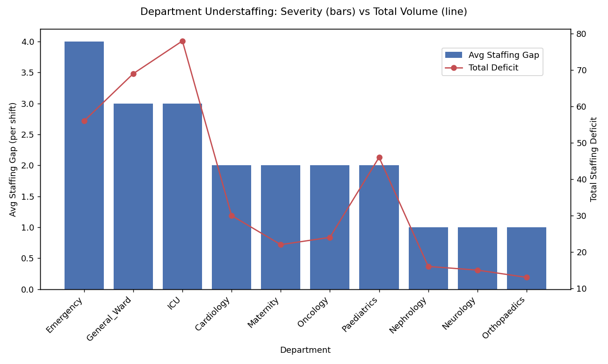

5.4 Finding
- Severity leader: Emergency (avg gap 4.0) — when short, it runs very short relative to requirement.
- Volume leader: ICU (total deficit 78) — not the worst per instance, but accumulates the largest total shortfall due to high instance count (26) combined with a consistently high gap.
- Mildest: Neurology, Orthopaedics, Nephrology — consistently low gap (1.0) and low totals.
Answer to Q1: Emergency has an acute severity problem; ICU has a chronic volume problem. These two departments are carried forward as the primary focus of the root-cause investigation.

6. Dive 2 (WHO) — Business Question 2

Which staff members or roles are accumulating the most overtime hours?
Analysed at two levels, per instruction: individual staff first (to spot personal overload/burnout risk), then rolled up by role (to see if it is systemic to a role or isolated to a few people).

6.1 Individual Level
staff_overtime = master.groupby(
["staff_id","staff_name","role","contract_type"]
).agg(
total_overtime_hrs=("overtime_hrs","sum"),
shifts_worked=("shift_id","count"),
avg_overtime_per_shift=("overtime_hrs","mean")
).reset_index()
Two different rankings were produced deliberately, because they answer different questions:
- Ranked by total_overtime_hrs — who has worked the most cumulative overtime (volume)
- Ranked by avg_overtime_per_shift — who is most overloaded on the shifts they do work (intensity)
Staff | Role | Contract | Total OT (hrs) | Shifts | Avg OT/Shift
Dr. Deepak Nair | Doctor | Full-Time | 11 | 13 | 0.85
Uma Rajan | Nurse | Full-Time | 11 | 9 | 1.19
Chitra Murthy | Nurse | Full-Time | 10 | 10 | 0.97
Bindu Singh | Nurse | Contract | 9 | 11 | 0.84
Ramesh Naik | Technician | Part-Time | 8 | 5 | 1.68
Sorted instead by avg_overtime_per_shift (intensity), the ranking changes substantially:
Staff | Role | Contract | Total OT (hrs) | Shifts | Avg OT/Shift
Ramesh Naik | Technician | Part-Time | 8 | 5 | 1.7
Dr. Suresh Pai | Doctor | Full-Time | 7 | 5 | 1.3
Dinesh Raju | Technician | Full-Time | 6 | 5 | 1.2
Swathi Nayak | Nurse | Full-Time | 7 | 6 | 1.2
Uma Rajan | Nurse | Full-Time | 11 | 9 | 1.19
Anomaly flagged: Ramesh Naik — a Part-Time Technician working only 5 shifts — has the single highest overtime intensity (1.7 hrs/shift) in the entire dataset. A part-time worker being pushed harder per shift than any full-time staff member is an anomaly worth investigating further under Business Question 7 (contract/part-time reliance).

6.2 Role Level
role_overtime = master.groupby("role").agg(
total_overtime_hrs=("overtime_hrs","sum"),
avg_overtime_per_shift=("overtime_hrs","mean"),
staff_count=("staff_id","nunique")
).reset_index()
role_overtime["overtime_per_staff"] = (
role_overtime["total_overtime_hrs"] / role_overtime["staff_count"]
).round(2)
Role | Total OT (hrs) | Avg OT/Shift | Staff Count | OT per Staff
Doctor | 40 | 0.92 | 8 | 5.0
Nurse | 79 | 0.80 | 20 | 3.9
Technician | 45 | 0.77 | 12 | 3.7
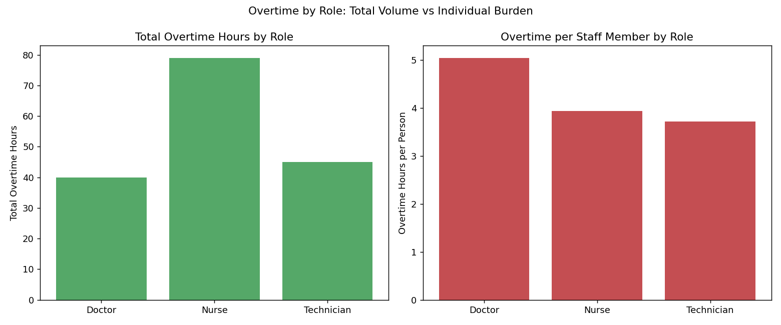

6.3 Finding
Answer to Q2: By total hours, Nurses appear to be the overtime 'problem' (79 hrs) — but this is a headcount effect (20 nurses vs. 8 doctors). Normalised per person, Doctors carry the heaviest burden: highest overtime per shift (0.92) AND highest overtime per staff member (5.0 hrs/doctor), despite having the fewest total hours. A total-hours-only report would have wrongly pointed at Nurses as the priority group.

7. Dive 3 (WHEN) — Business Question 3

Which departments have the highest absenteeism rate, and on which days of the week does absence peak?

7.1 Department Absenteeism
dept_absence = master.groupby("dept_name").agg(
total_shifts=("shift_id","count"),
absent_shifts=("absent_flag","sum")
).reset_index()
dept_absence["absenteeism_rate_pct"] = (
dept_absence["absent_shifts"] / dept_absence["total_shifts"] * 100
).round(1)
Department | Total Shifts | Absent Shifts | Absenteeism %
Orthopaedics | 18 | 5 | 27.8
Emergency | 18 | 4 | 22.2
Maternity | 14 | 3 | 21.4
Cardiology | 19 | 4 | 21.1
ICU | 32 | 6 | 18.8
Oncology | 14 | 2 | 14.3
General_Ward / Paediatrics | 26 each | 3 each | 11.5
Neurology | 16 | 1 | 6.2
Nephrology | 17 | 1 | 5.9

7.2 Weekday Absenteeism — Sort Order Fix
day_of_week is stored as text ("Monday", "Tuesday", ...), which sorts alphabetically by default (Friday, Monday, Saturday...) rather than chronologically. Since this same table will later be loaded into Power BI, a numeric helper column was added so the correct Monday→Sunday order can be enforced in both tools — in pandas via sort_values, and in Power BI via the 'Sort by Column' feature.
weekday_order = {"Monday":1,"Tuesday":2,"Wednesday":3,"Thursday":4,
"Friday":5,"Saturday":6,"Sunday":7}
master["day_of_week_num"] = master["day_of_week"].map(weekday_order)
weekday_absence = master.groupby(["day_of_week","day_of_week_num"]).agg(
total_shifts=("shift_id","count"),
absent_shifts=("absent_flag","sum")
).reset_index()
weekday_absence["absenteeism_rate_pct"] = (
weekday_absence["absent_shifts"] / weekday_absence["total_shifts"] * 100
).round(1)
weekday_absence = weekday_absence.sort_values("day_of_week_num")
Day | Total Shifts | Absent Shifts | Absenteeism %
Monday | 32 | 6 | 18.8
Tuesday | 22 | 3 | 13.6
Wednesday | 28 | 4 | 14.3
Thursday | 28 | 2 | 7.1
Friday | 29 | 7 | 24.1
Saturday | 36 | 5 | 13.9
Sunday | 25 | 5 | 20.0
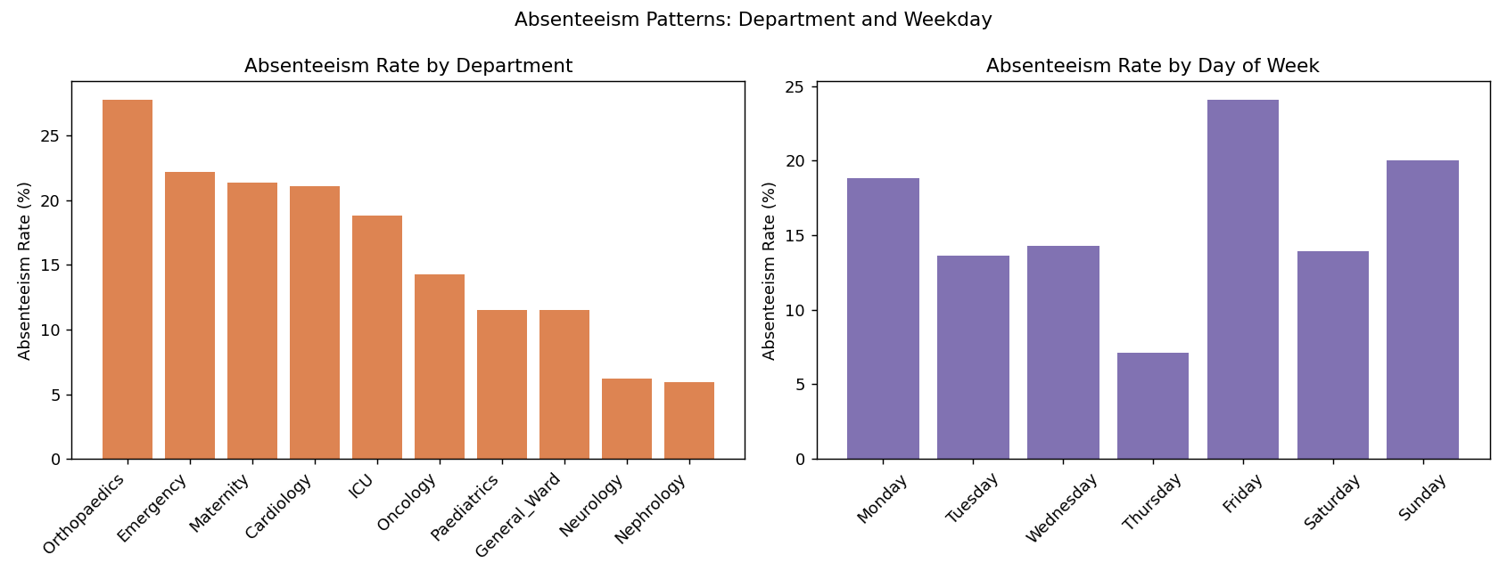

7.3 Finding
- Sample sizes across departments (14–32 shifts) and weekdays (22–36 shifts) were checked and judged large enough to trust these rates, unlike the sparse Q1 data.
- Orthopaedics has the highest absence rate overall (27.8%), despite being one of the mildest departments for understaffing in Q1 — a disconnect investigated further in the root-cause section.
- Absence clusters around Friday and the weekend edge (Fri 24.1%, Sun 20.0%, Mon 18.8%), while Thursday is lowest (7.1%) — a pattern flagged for the storyboard but not assigned a cause without further data.
Answer to Q3: Orthopaedics has the highest absenteeism (27.8%); absence peaks on Friday, with elevated levels also on Sunday and Monday, forming a weekend-adjacent pattern.

8. Dive 4 (HOW MUCH) — Business Question 4

How many patients is each staff member attending to per shift — and is this workload evenly distributed?
"Evenly distributed" requires looking at spread (variation), not just the average — a high average with low spread means the load is shared fairly; a high average with high spread means a few people carry much more than others.
workload_spread = master.groupby("role")["patients_attended"].agg(
mean_patients="mean", std_patients="std",
min_patients="min", max_patients="max"
).reset_index()
Role | Mean Patients/Shift | Std Dev | Min | Max
Doctor | 5.0 | 3.0 | 0 | 11
Nurse | 9.2 | 3.7 | 0 | 15
Technician | 6.5 | 3.8 | 0 | 12
On raw std dev vs. relative variability: Nurses have the highest raw standard deviation (3.7), which looks least even at first glance — but relative to their own mean (9.2), that's about 40% variability. Doctors (std 3.0 on mean 5.0) and Technicians (std 3.8 on mean 6.5) actually show higher relative variability (~55-60%). Proportionally, Doctors and Technicians have less even workload distribution than Nurses, despite Nurses having the larger absolute numbers. This is why the coefficient of variation (std ÷ mean), not raw std, is the fairer 'evenness' comparison across roles with different baseline loads.
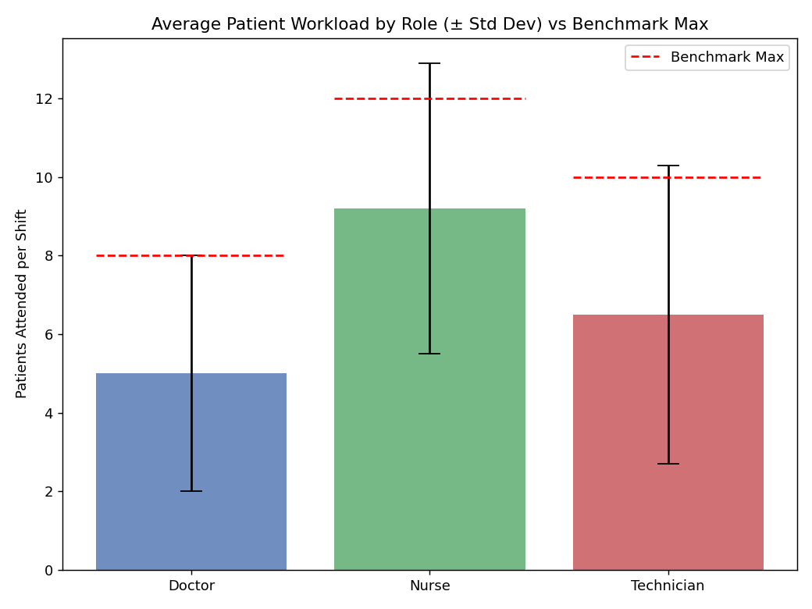
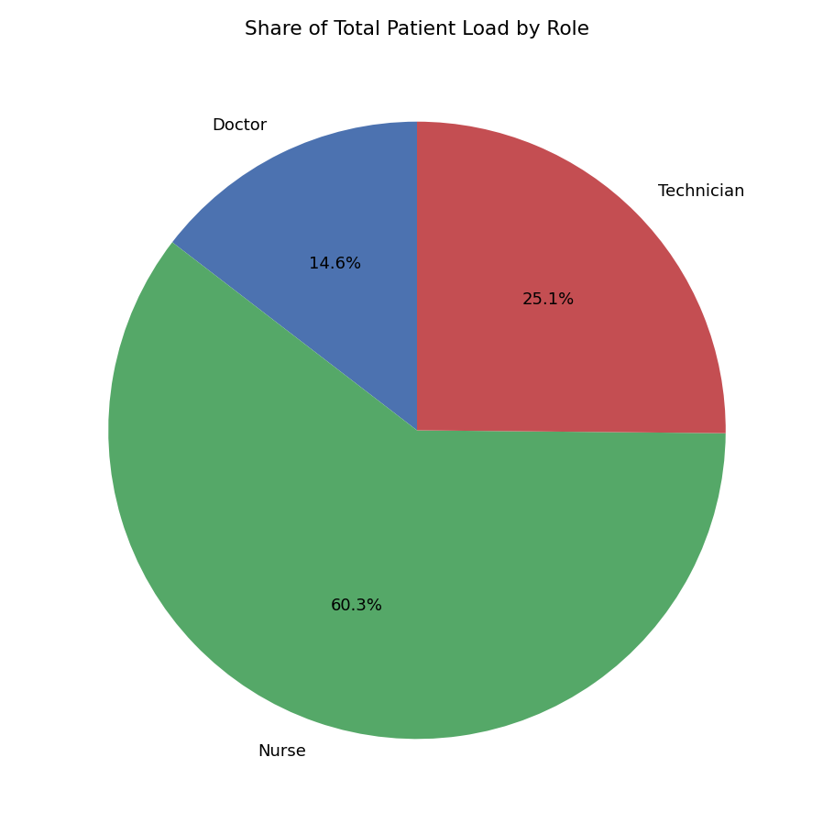

8.1 Benchmark Violations
Beyond relative evenness, each shift's patient count was checked directly against that role's safe maximum from role_benchmark.csv:
master["over_benchmark"] = master["patients_attended"] > master["max_patients_per_shift"]
print(master["over_benchmark"].sum(), "shifts exceeded the safe max") # 15 of 200 (7.5%)
15 of 200 shifts (7.5%) exceeded the role's recommended maximum patient load. Critically, these were not randomly spread — specific individuals appeared more than once (e.g. Swathi Nayak, Savitha Gowda, Chitra Murthy each violated twice), and all three doctors who violated the benchmark did so by a large proportional margin (e.g. 11 patients against a max of 8 — a 38% overload).
Cross-reference: Dr. Deepak Nair and Dr. Suresh Pai — both flagged in Q2 for high overtime intensity — also appear in this benchmark-violation list. This is the first convergence of evidence across two separate business questions pointing at the same individuals, and it is carried forward into the root-cause layer.
Answer to Q4: Workload is not evenly distributed. Doctors and Technicians show proportionally more variability than Nurses despite lower averages, and a specific small set of individuals (repeat violators, particularly some Nurses and 3 Doctors) are regularly exceeding safe patient-load benchmarks — this is an individual overload pattern, not a role-wide problem.

9. Business Question 5

Which shift type (Morning, Evening, Night) is the most understaffed and has the highest overtime?
shift_understaffing = staffing_actual.groupby("shift_type").agg(
total_shift_instances=("understaffed","count"),
avg_staffing_gap=("staffing_gap","mean"),
total_staffing_deficit=("staffing_gap","sum")
).reset_index()
shift_overtime = master.groupby("shift_type").agg(
total_overtime_hrs=("overtime_hrs","sum"),
avg_overtime_per_shift=("overtime_hrs","mean")
).reset_index()
Shift | Instances | Avg Staffing Gap | Avg Overtime/Shift
Morning | 57 | 2.3 | 0.84
Night | 53 | 2.3 | 0.75
Evening | 58 | 2.0 | 0.87
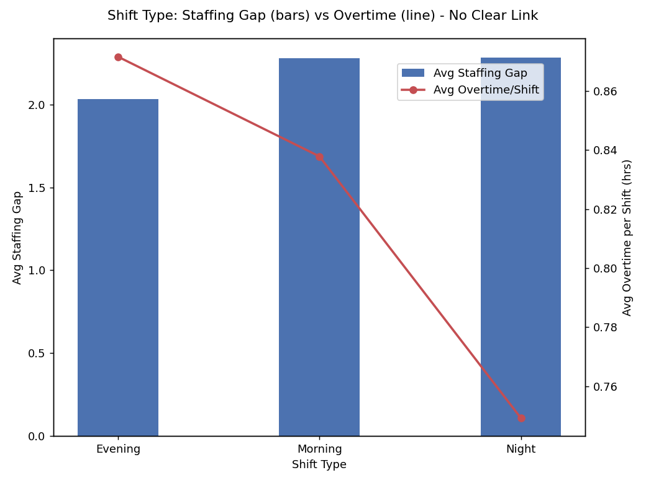
Morning and Night are tied for worst understaffing severity (2.3), while Evening is slightly better (2.0) — yet Evening has the highest overtime (0.87), and Night, despite being tied-worst for understaffing, has the lowest overtime (0.75). This is a direct disconnect: if understaffing mechanically forced overtime, Night should show the most overtime, not the least.

9.1 Testing Alternative Explanations
Two follow-up checks were run to see if something else explained Evening's overtime lead:
shift_workload = master.groupby("shift_type")["patients_attended"].mean().round(1)
# Evening 7.7, Morning 7.7, Night 7.2 — no meaningful difference
shift_contract_mix = master.groupby(["shift_type","contract_type"]).size().unstack(fill_value=0)
# Evening: Contract 10, Full-Time 48, Part-Time 9
# Morning: Contract 9, Full-Time 53, Part-Time 4
# Night: Contract 13, Full-Time 43, Part-Time 11
# Contract/part-time share is roughly proportional across shifts — Night actually
# has slightly MORE contract+part-time staff than Evening, the opposite of what
# would explain Evening's overtime lead.
Answer to Q5: Evening has the highest overtime, but neither staffing severity, patient workload, nor contract-type mix explain why — all three were tested and ruled out. This is reported honestly as an open finding: something specific to Evening shifts (e.g. scheduling practice, shift-handover patterns) is driving overtime that isn't visible in this dataset, rather than inventing an explanation the data doesn't support.

10. Business Question 6

What is the total overtime cost incurred per department over the 12-month period?
master["overtime_cost"] = master["overtime_hrs"] * master["hourly_rate"]
dept_overtime_cost = master.groupby("dept_name").agg(
total_overtime_cost=("overtime_cost","sum"),
total_overtime_hrs=("overtime_hrs","sum")
).reset_index()
Department | Total Overtime Cost (Rs) | Total OT Hours
Paediatrics | 11,298 | 26.5
General_Ward | 10,834 | 25.8
Orthopaedics | 9,229 | 16.9
Cardiology | 8,546 | 19.9
ICU | 7,929 | 16.7
Neurology | 6,015 | 16.4
Maternity | 4,388 | 13.0
Emergency | 4,109 | 11.4
Nephrology | 3,248 | 9.4
Oncology | 1,813 | 7.9
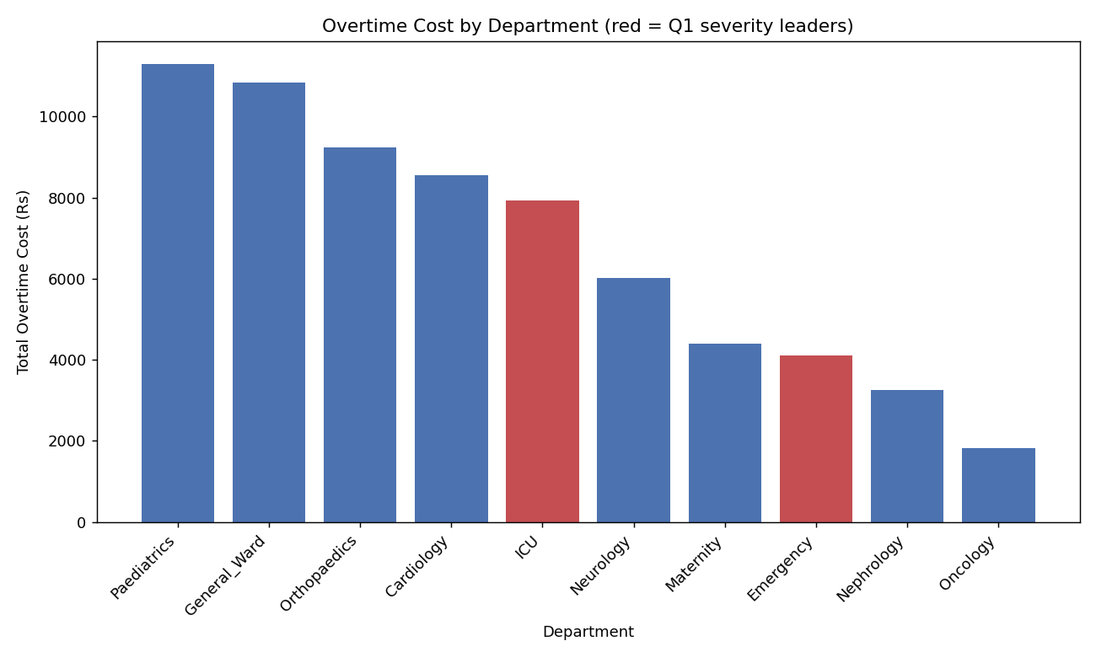
Disconnect from Q1: Paediatrics tops the cost list despite only moderate understaffing severity in Q1 (avg gap 2.0). Emergency — the Q1 severity leader — has one of the lowest overtime costs. ICU — the Q1 volume leader — is only mid-pack. The departments with the worst staffing gaps are NOT the departments with the highest overtime cost.

10.1 Testing Role Mix as an Explanation
dept_role_mix = master.groupby(["dept_name","role"]).size().unstack(fill_value=0)
Department | Doctors | Nurses | Technicians
Paediatrics | 4 | 12 | 10
General_Ward | 5 | 13 | 8
Emergency | 6 | 5 | 7
ICU | 7 | 16 | 9
Paediatrics and General_Ward do have solid nurse counts, partially consistent with Q2's finding that Nurses carry the highest total overtime hours as a group. But ICU has the MOST nurses (16) of all four and still lands only mid-pack on cost — so nurse headcount alone does not fully explain the pattern.
Answer to Q6: Paediatrics (Rs 11,298) and General_Ward (Rs 10,834) incur the highest overtime cost. Role mix (more nurses) is a partial explanation but not a complete one — cost is not simply explained by staffing severity or role headcount, and is carried into the correlation analysis for a fuller answer.

11. Business Question 7

Are contract and part-time staff being relied upon to cover gaps that should be filled by full-time employees?
contract_reliance = master.groupby(["dept_name","contract_type"]).size().unstack(fill_value=0)
contract_reliance["total"] = contract_reliance.sum(axis=1)
contract_reliance["contract_pct"] = (
(contract_reliance.get("Contract",0) + contract_reliance.get("Part-Time",0))
/ contract_reliance["total"] * 100
).round(1)
Department | Contract | Full-Time | Part-Time | Contract+PT %
Cardiology | 5 | 8 | 6 | 57.9
Oncology | 3 | 9 | 2 | 35.7
General_Ward | 6 | 18 | 2 | 30.8
Paediatrics | 3 | 18 | 5 | 30.8
Orthopaedics | 1 | 13 | 4 | 27.8
ICU | 6 | 24 | 2 | 25.0
Emergency | 3 | 14 | 1 | 22.2
Neurology | 1 | 13 | 2 | 18.8
Nephrology | 3 | 14 | 0 | 17.6
Maternity | 1 | 13 | 0 | 7.1
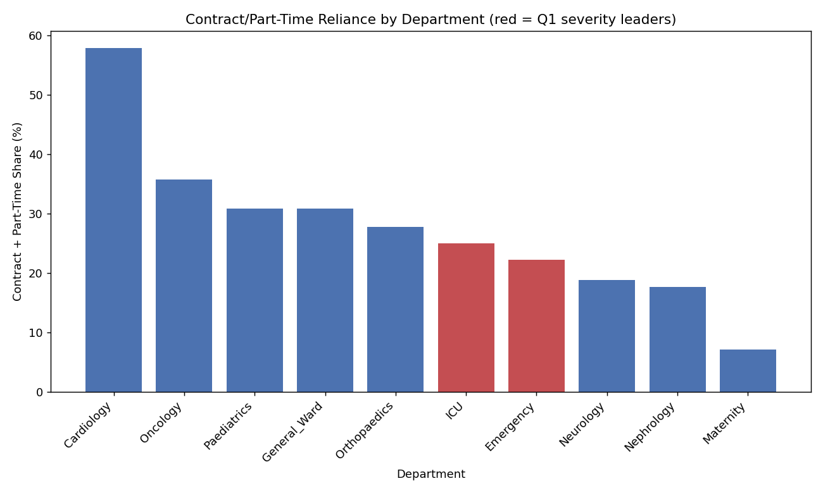
Answer to Q7: No evidence supports the theory that contract/part-time staff are plugging the worst staffing gaps. Cardiology has by far the highest contract reliance (57.9%) yet was only moderately understaffed in Q1. Emergency (22.2%) and ICU (25.0%) — the two real crisis departments — are staffed predominantly by Full-Time employees and still fall short. This means the Emergency/ICU shortfall cannot be blamed on under-investment in permanent staff; a contract-staffing fix would not address the actual gap.

12. Dive 5-7 — Root Cause Analysis
All seven business questions were answered individually, but each was treated as evidence, not a conclusion. This section tests the relationships between them statistically to find what actually explains the Emergency/ICU staffing crisis.

12.1 Combined Department Summary
Department | Avg Gap | Total Deficit | Absence % | OT Cost | Contract % | Criticality
Cardiology | 2.0 | 30 | 21.1 | 8,546 | 57.9 | High
Emergency | 4.0 | 56 | 22.2 | 4,109 | 22.2 | High
General_Ward | 3.0 | 69 | 11.5 | 10,834 | 30.8 | Low
ICU | 3.0 | 78 | 18.8 | 7,929 | 25.0 | High
Maternity | 2.0 | 22 | 21.4 | 4,388 | 7.1 | Medium
Nephrology | 1.0 | 16 | 5.9 | 3,248 | 17.6 | Medium
Neurology | 1.0 | 15 | 6.2 | 6,015 | 18.8 | High
Oncology | 2.0 | 24 | 14.3 | 1,813 | 35.7 | Medium
Orthopaedics | 1.0 | 13 | 27.8 | 9,229 | 27.8 | Medium
Paediatrics | 2.0 | 46 | 11.5 | 11,298 | 30.8 | Medium

12.2 Correlation Matrix
dept_summary[corr_cols].corr().round(2)
 | Avg Gap | Total Deficit | Absence % | OT Cost | Contract %
Avg Gap | 1.00 | 0.84 | 0.29 | 0.06 | 0.07
Total Deficit | 0.84 | 1.00 | 0.06 | 0.41 | 0.11
Absence % | 0.29 | 0.06 | 1.00 | 0.11 | 0.17
OT Cost | 0.06 | 0.41 | 0.11 | 1.00 | 0.36
Contract % | 0.07 | 0.11 | 0.17 | 0.36 | 1.00
Caution on small sample: With only 10 departments, a correlation coefficient can swing heavily based on just one or two outlier departments. Results below were interpreted alongside the actual data, not the coefficient alone.

12.3 What Does NOT Explain the Staffing Gap
- avg_staffing_gap ↔ absenteeism_rate_pct = 0.29 (weak) — the Emergency/ICU pattern seen earlier is not a strong dataset-wide relationship.
- avg_staffing_gap ↔ total_overtime_cost = 0.06 (essentially zero) — confirms Q6's finding numerically: staffing severity and overtime cost are unrelated.
- avg_staffing_gap ↔ contract_pct = 0.07 (essentially zero) — confirms Q7's finding numerically: contract reliance is unrelated to staffing severity.

12.4 What Does Explain It: Criticality
dept_summary.groupby("criticality")[corr_cols].mean().round(2)
Criticality | Avg Gap | Total Deficit | Absence % | OT Cost | Contract %
High (n=4) | 2.5 | 44.75 | 17.08 | 6,649.75 | 30.98
Medium (n=5) | 1.6 | 24.20 | 16.18 | 5,995.20 | 23.80
Low (n=1)* | 3.0 | 69.00 | 11.50 | 10,834.00 | 30.80
Note on 'Low' criticality: Low criticality contains only one department (General_Ward), so its row is that single department's numbers, not a group average. It is reported as General_Ward specifically, not generalised as a 'Low criticality trend' — treating n=1 as a pattern would be an overclaim.
Comparing the two groups with multiple departments (High n=4 vs Medium n=5):
- Avg staffing gap: High 2.5 vs Medium 1.6 — a real, meaningful difference
- Total staffing deficit: High 44.75 vs Medium 24.20 — nearly double; the clearest signal in the whole analysis
- Absenteeism: High 17.08 vs Medium 16.18 — essentially identical, no real relationship
- Overtime cost: High 6,649.75 vs Medium 5,995.20 — close, not meaningful
- Contract %: High 30.98 vs Medium 23.80 — somewhat higher, but modest
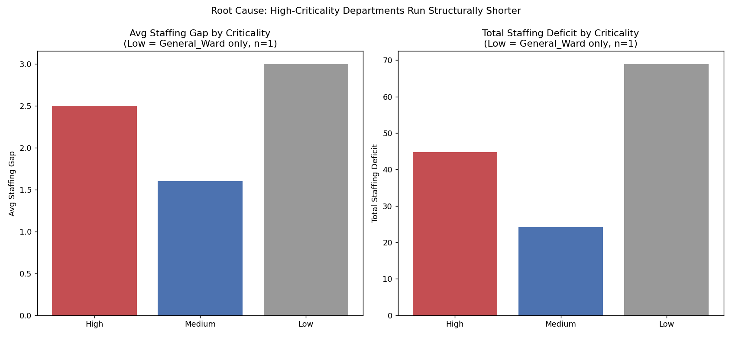

12.5 Root Cause Conclusion
Root cause: The one factor that genuinely separates the strained departments from the rest is operational criticality itself. High-criticality departments carry a meaningfully worse staffing gap and total deficit than Medium ones — while absenteeism, overtime cost, and contract reliance do NOT meaningfully track with criticality. The Emergency/ICU shortfall is structural: departments classified as most critical are not receiving proportionally higher staffing coverage relative to their own requirement, and none of the operational factors tested (absence, cost, contract mix) explain or excuse the gap.

13. Dive 8 — Impact Assessment
The root cause (criticality-driven structural under-resourcing) is translated into cost and risk terms for the four High-criticality departments, combining staffing deficit, overtime cost, and patient-safety benchmark violations.
high_crit_impact = master[master["dept_name"].isin(
["Cardiology","Emergency","ICU","Neurology"]
)].groupby("dept_name").agg(
total_overtime_cost=("overtime_cost","sum"),
total_shifts_affected=("shift_id","count"),
benchmark_violations=("over_benchmark","sum")
).reset_index()
Department | OT Cost (Rs) | Shifts | Benchmark Violations | Staffing Deficit
ICU | 7,929 | 32 | 3 | 78
Emergency | 4,109 | 18 | 0 | 56
Cardiology | 8,546 | 19 | 3 | 30
Neurology | 6,015 | 16 | 2 | 15

13.1 Three Distinct Risk Profiles
- ICU — deficit + safety risk: highest staffing deficit (78) AND highest shift volume (32) AND 3 benchmark violations. The shortfall most often translates into unsafe patient loads.
- Cardiology — cost + safety risk without large deficit: highest overtime cost (Rs 8,546) of the four and 3 benchmark violations, despite the smallest staffing deficit (30) in this group — its strain is not primarily a headcount story.
- Emergency — severe deficit, no safety breach yet: worst avg staffing gap in the whole dataset, but zero benchmark violations — a real gap that has not (yet) become a patient-safety issue, worth monitoring before it does.
- Neurology — mildest of the four across all metrics.
Why this matters: Not all High-criticality departments need the same intervention. ICU needs headcount investment. Cardiology needs its cost and workload drivers investigated separately from staffing levels. Emergency needs close monitoring as an early-warning case before its deficit becomes a safety issue too.

14. Storyboard Narrative & Recommendations
The client-facing storyboard (built next in Power BI) follows this narrative arc — tested, cause-led, and ending in specific, differentiated recommendations rather than a generic 'hire more staff.'

Recommended narrative order
- 1. Opening: Staffing shortfalls exist hospital-wide, but not equally — some departments carry real risk, others don't.
- 2. Where it's worst: Emergency (acute severity) and ICU (chronic volume) — two different problems, both real.
- 3. Who's carrying the strain: Doctors carry the heaviest overtime burden per person, despite Nurses showing the highest total — the workforce most stretched isn't who a totals-only report would suggest.
- 4. When it shows up: Absence peaks Friday/weekend-edge; Orthopaedics has the highest absence rate even though it isn't severely understaffed — an early-warning signal worth tracking.
- 5. Is the workload fair: A specific small set of individuals (a few Nurses, three Doctors) regularly exceed safe patient-load benchmarks — some of the same people also carry the heaviest overtime.
- 6. Ruling out the obvious explanations: Evening's overtime, department overtime cost, and contract/part-time reliance were all tested against the staffing crisis and none explain it.
- 7. Root cause: Criticality classification itself — High-criticality departments run a meaningfully worse staffing gap, independent of absence, cost, or contract mix.
- 8. Impact: ICU (deficit+safety), Cardiology (cost+safety), Emergency (deficit, early warning) — three distinct risk profiles needing three distinct responses.

Recommendations
- Review required-staffing allocation specifically for High-criticality departments, prioritising ICU first.
- Monitor Emergency closely — its staffing gap is the most severe in the hospital and has not yet produced a safety-benchmark breach, but is at risk of doing so.
- Investigate Cardiology's cost and Doctor-role overload drivers separately from headcount, since its strain is not primarily a staffing-volume issue.
- Treat Orthopaedics' high absenteeism as an early-warning metric to track, even though it is not currently a severely understaffed department.
- Do not treat contract/part-time staffing policy as a lever for fixing the Emergency/ICU crisis — the data does not support that connection.

15. Anticipated Questions & Answers (Viva / Teacher Prep)

Q: Why did you drop the 'percent understaffed' metric after finding 100% everywhere?
Because the dataset only covers about 1.5% of all possible shift-instances in a year (168 of 10,950). Comparing a partial actual-staff count to a full-year requirement makes every group look 100% short by mathematical default — it was a data-scope artifact, not a real finding. I verified this with a coverage check before accepting or rejecting the metric, rather than either blindly trusting or blindly dismissing the surprising result.

Q: What's the difference between avg_staffing_gap and total_staffing_deficit, and why report both?
avg_staffing_gap measures severity — how short-staffed a department is, on average, on the shifts where we do have a record. total_staffing_deficit measures volume — the sum of all gaps, which is naturally larger for departments with more logged shift instances. Reporting both avoids two different mistakes: judging severity by volume alone (which unfairly penalises departments with more data points) or judging volume by severity alone (which would understate a chronic, high-frequency problem like ICU's).

Q: How did you test whether your 'root cause' claim was real, rather than just a guess from looking at two departments?
I built a department-level summary table combining every metric (staffing gap, absenteeism, overtime cost, contract %, criticality) and ran a correlation matrix across all ten departments — not just the two that first caught my eye (Emergency, ICU). The Emergency/ICU-vs-absenteeism pattern that looked compelling with two data points only showed a weak correlation (0.29) across all ten. What did hold up consistently was the criticality group comparison — High-criticality departments averaged a meaningfully worse staffing gap (2.5 vs 1.6) and total deficit (44.75 vs 24.20) than Medium ones, while absenteeism, cost and contract-mix showed no such gap between the two groups.

Q: Why is your 'Low criticality' row treated differently in the report?
Because it represents exactly one department (General_Ward) — n=1. Averaging a single data point and calling it a group trend would be statistically misleading, so I labelled it explicitly as General_Ward's own numbers rather than implying a 'Low-criticality pattern' that the data cannot support with only one example.

Q: Why does Emergency have the worst staffing gap but zero benchmark violations, while ICU has both a bad gap and violations?
They represent different stages/types of risk. Emergency's shortfall is severe on paper (fewest staff relative to requirement) but hasn't yet translated into patients receiving unsafe caseloads — possibly because Emergency's overall patient volume in the logged shifts wasn't extreme enough to cross the threshold. ICU combines a high total deficit with a high patient-attended workload, which did push several shifts over the safe benchmark. This is why I reported them as two different risk profiles requiring different responses, rather than ranking departments on a single 'risk score.'

Q: Why didn't you just say contract staff are covering the gaps, since that's a common assumption in staffing analyses?
Because I tested it directly rather than assuming it. Cardiology has the highest contract/part-time reliance (57.9%) but only a moderate staffing gap, while Emergency and ICU — the two departments with genuine staffing crises — are staffed mostly by Full-Time employees (77.8% and 75% Full-Time respectively) and still fall short. The correlation between contract_pct and avg_staffing_gap across all departments is essentially zero (0.07). So the data actively contradicts the 'contract staff covering gaps' assumption rather than supporting it.

Q: What would you do differently with more data?
The sparse shift-record coverage (200 records vs. 10,950 possible shift-instances) limits how confidently we can generalise some findings, especially anything based on daily/weekday granularity. With a full year of complete shift logs, I would re-run the same methodology (severity, volume, correlation, criticality comparison) with much higher confidence, and could also test additional factors such as staff experience level or seasonal/monthly trends, which the current sample is too thin to support reliably.

Q: Why translate everything into non-technical language for the client instead of showing the Python/statistics work?
Because the client's decision-makers need to know what's wrong, why, what it costs, and what to do — not how the analysis was performed. The technical methodology (this document) exists to make sure every claim in the client-facing storyboard is defensible and tested, but the storyboard itself is written so a non-technical hospital administrator can act on it without needing to understand a correlation coefficient or a groupby statement.

16. SQL Phase — MySQL Verification
Every business question and the full root-cause layer were rebuilt independently in MySQL, using the raw cleaned CSVs imported directly into a relational schema (not exported from the Python master table). Each result was compared line-by-line against the Python output. This section documents the schema, the queries, two real bugs that were caught and fixed, and the final verification that both tools agree.

16.1 Schema Setup
Five tables were created with explicit primary keys and foreign key constraints linking shifts to staff, department, and dates:
CREATE DATABASE IF NOT EXISTS hospital_staffs;
USE hospital_staffs;
CREATE TABLE staff (
staff_id VARCHAR(10) PRIMARY KEY, staff_name VARCHAR(100), role VARCHAR(20),
experience_yrs INT, contract_type VARCHAR(20), hourly_rate DECIMAL(10,2)
);
CREATE TABLE department (
dept_id VARCHAR(10) PRIMARY KEY, dept_name VARCHAR(50),
required_staff_per_shift INT, criticality VARCHAR(10)
);
CREATE TABLE dates (
date_id VARCHAR(15) PRIMARY KEY, full_date DATE, day_of_week VARCHAR(10),
month INT, quarter INT, year INT, is_weekend BOOLEAN
);
CREATE TABLE role_benchmark (
role VARCHAR(20) PRIMARY KEY, max_patients_per_shift INT,
standard_shift_hrs INT, overtime_threshold_hrs INT
);
CREATE TABLE shifts (
shift_id VARCHAR(10) PRIMARY KEY, staff_id VARCHAR(10), dept_id VARCHAR(10),
date_id VARCHAR(15), shift_date DATE, shift_type VARCHAR(10),
hours_worked DECIMAL(4,1), overtime_hrs DECIMAL(4,1),
patients_attended INT, absent_flag BOOLEAN,
FOREIGN KEY (staff_id) REFERENCES staff(staff_id),
FOREIGN KEY (dept_id) REFERENCES department(dept_id),
FOREIGN KEY (date_id) REFERENCES dates(date_id)
);

16.2 Bug #1 — Floating-Point Display Artifact
Summing DECIMAL columns in MySQL (e.g. SUM(overtime_hrs)) can display results like 9.700000000000001 instead of 9.7. This is not a data error — it is a binary floating-point representation artifact during aggregation. Pandas hides this by rounding on display; MySQL does not unless told to.
-- Before: sum(sh.overtime_hrs) -> 9.700000000000001
-- After: round(sum(sh.overtime_hrs), 1) -> 9.7
Fix applied: Every SUM() over a decimal column was wrapped in ROUND(..., n) throughout the script.

16.3 Bug #2 — Boolean Stored as Text (the serious one)
absent_flag was defined as BOOLEAN in the schema, but the CSV import stored the literal strings 'True' and 'False', not MySQL's native 0/1 boolean.
select absent_flag, count(*) from shifts group by absent_flag;
-- False 168
-- True 32
This caused two separate failures:
- SUM(sh.absent_flag) silently returned 0 for every group, because MySQL could not convert the text 'True'/'False' into a summable number — Q3's first attempt showed 0% absenteeism for every department and every weekday.
- WHERE s.absent_flag = false in the staffing_actual view silently matched every row, not just present staff, because MySQL coerced both the text value and the boolean literal to 0 for comparison — this inflated Q1 and Q5's shift-instance counts and staffing deficits (e.g. Q5 initially showed 66/66/67 instances instead of the correct 57/53/58) without throwing any error.
Fix applied: Every comparison and aggregation involving absent_flag was rewritten to compare the actual text values explicitly: WHERE absent_flag = 'False' for filtering, and SUM(CASE WHEN absent_flag = 'True' THEN 1 ELSE 0 END) for counting. The staffing_actual view was dropped and recreated with the corrected filter, and every downstream query built on that view (Q1, Q5, the root-cause dept_summary view) was re-verified afterward.
Why this matters for the project: This bug did not cause an error message — it executed successfully and returned plausible-looking numbers. It was only caught by independently cross-checking every SQL result against the already-verified Python output, rather than trusting either tool in isolation. This is a genuine argument for why the two-tool verification approach used in this project (Python then MySQL, line-by-line comparison) is good practice, not redundant effort.

16.4 Business Questions 1-7 — Verified Queries & Results
Each question below reproduces the exact result already established in Python (Sections 5-11 of this document). Only the SQL implementation is shown here; the interpretation is unchanged.

Q1 — Understaffed Departments
create view staffing_actual as
select d.dept_id, d.dept_name, s.shift_date, s.shift_type,
d.required_staff_per_shift, count(*) as actual_staff
from shifts s
join department d on s.dept_id = d.dept_id
where s.absent_flag = 'False'
group by d.dept_id, d.dept_name, s.shift_date, s.shift_type, d.required_staff_per_shift;
select dept_name, count(*) as total_shift_instances,
round(avg(staffing_gap), 1) as avg_staffing_gap,
sum(staffing_gap) as total_staffing_deficit
from (
select dept_name, (required_staff_per_shift - actual_staff) as staffing_gap
from staffing_actual
) t
group by dept_name
order by avg_staffing_gap desc;
Result: Emergency 14/4.0/56, ICU 26/3.0/78, General_Ward 23/3.0/69 — exact match with Python after the view fix.

Q2 — Overtime Accumulation (Individual + Role)
select st.staff_id, st.staff_name, st.role, st.contract_type,
round(sum(sh.overtime_hrs), 1) as total_overtime_hrs,
count(*) as shifts_worked,
round(avg(sh.overtime_hrs), 2) as avg_overtime_per_shift
from shifts sh join staff st on sh.staff_id = st.staff_id
group by st.staff_id, st.staff_name, st.role, st.contract_type
order by avg_overtime_per_shift desc limit 10;
select st.role, round(sum(sh.overtime_hrs), 1) as total_overtime_hrs,
round(avg(sh.overtime_hrs), 2) as avg_overtime_per_shift,
count(distinct st.staff_id) as staff_count,
round(sum(sh.overtime_hrs) / count(distinct st.staff_id), 2) as overtime_per_staff
from shifts sh join staff st on sh.staff_id = st.staff_id
group by st.role order by total_overtime_hrs desc;
Result: Ramesh Naik top by intensity (1.68/shift); Nurse highest total (78.8 hrs) but Doctor highest per-person (5.05) — exact match with Python.

Q3 — Absenteeism by Department and Weekday
select d.dept_name, count(*) as total_shifts,
sum(case when sh.absent_flag = 'True' then 1 else 0 end) as absent_shifts,
round(sum(case when sh.absent_flag = 'True' then 1 else 0 end) / count(*) * 100, 1) as absenteeism_rate_pct
from shifts sh join department d on sh.dept_id = d.dept_id
group by d.dept_name order by absenteeism_rate_pct desc;
select dt.day_of_week,
case dt.day_of_week when 'Monday' then 1 when 'Tuesday' then 2
when 'Wednesday' then 3 when 'Thursday' then 4 when 'Friday' then 5
when 'Saturday' then 6 when 'Sunday' then 7 end as day_of_week_num,
count(*) as total_shifts,
sum(case when sh.absent_flag = 'True' then 1 else 0 end) as absent_shifts,
round(sum(case when sh.absent_flag = 'True' then 1 else 0 end) / count(*) * 100, 1) as absenteeism_rate_pct
from shifts sh join dates dt on sh.date_id = dt.date_id
group by dt.day_of_week order by day_of_week_num;
Result: Orthopaedics highest (27.8%); Friday highest weekday (24.1%), Thursday lowest (7.1%) — exact match with Python.

Q4 — Patient Workload & Benchmark Violations
select st.role, round(avg(sh.patients_attended), 1) as mean_patients,
round(stddev(sh.patients_attended), 1) as std_patients,
min(sh.patients_attended) as min_patients, max(sh.patients_attended) as max_patients
from shifts sh join staff st on sh.staff_id = st.staff_id
group by st.role;
select count(*) as total_violations
from shifts sh
join staff st on sh.staff_id = st.staff_id
join role_benchmark rb on st.role = rb.role
where sh.patients_attended > rb.max_patients_per_shift;
Result: role spread matches Python (Doctor/Technician proportionally less even than Nurse); 15 total benchmark violations, same repeat offenders — exact match with Python.

Q5 — Shift Type Comparison
select shift_type, count(*) as total_shift_instances,
round(avg(required_staff_per_shift - actual_staff), 1) as avg_staffing_gap,
sum(required_staff_per_shift - actual_staff) as total_staffing_deficit
from staffing_actual
group by shift_type order by avg_staffing_gap desc;
select sh.shift_type, round(sum(sh.overtime_hrs), 1) as total_overtime_hrs,
round(avg(sh.overtime_hrs), 2) as avg_overtime_per_shift, count(*) as shifts_count
from shifts sh group by sh.shift_type order by avg_overtime_per_shift desc;
Result (after the view-bug fix): Morning 57/2.3/130, Night 53/2.3/121, Evening 58/2.0/118 for staffing; Evening highest overtime (0.87) despite not the worst gap — patient workload and contract mix both tested and ruled out as explanations — exact match with Python.

Q6 — Overtime Cost per Department
select d.dept_name, round(sum(sh.overtime_hrs * st.hourly_rate), 0) as total_overtime_cost,
round(sum(sh.overtime_hrs), 1) as total_overtime_hrs
from shifts sh
join staff st on sh.staff_id = st.staff_id
join department d on sh.dept_id = d.dept_id
group by d.dept_name order by total_overtime_cost desc;
Result: Paediatrics Rs 11,298 highest, Oncology Rs 1,813 lowest — exact match with Python.

Q7 — Contract/Part-Time Reliance
select d.dept_name,
sum(case when st.contract_type = 'Full-Time' then 1 else 0 end) as full_time,
sum(case when st.contract_type = 'Contract' then 1 else 0 end) as contract,
sum(case when st.contract_type = 'Part-Time' then 1 else 0 end) as part_time,
count(*) as total,
round(sum(case when st.contract_type in ('Contract','Part-Time') then 1 else 0 end) / count(*) * 100, 1) as contract_pct
from shifts sh
join staff st on sh.staff_id = st.staff_id
join department d on sh.dept_id = d.dept_id
group by d.dept_name order by contract_pct desc;
Result: Cardiology highest (57.9%), Maternity lowest (7.1%); Emergency (22.2%) and ICU (25.0%) both below several other departments — exact match with Python, confirming contract reliance does not explain the Emergency/ICU crisis.

16.5 Root-Cause Layer in SQL
The combined department-summary view was rebuilt in SQL by joining four separately-aggregated subqueries (staffing gap, absenteeism, overtime cost, contract %) plus the department table for criticality:
create view dept_summary as
select u.dept_name, u.avg_staffing_gap, u.total_staffing_deficit,
a.absenteeism_rate_pct, c.total_overtime_cost, r.contract_pct, d.criticality
from (
select dept_name, round(avg(staffing_gap),1) as avg_staffing_gap,
sum(staffing_gap) as total_staffing_deficit
from (select dept_name, (required_staff_per_shift - actual_staff) as staffing_gap
from staffing_actual) t
group by dept_name
) u
join ( /* absenteeism_rate_pct by department, as in Q3 */ ) a on u.dept_name = a.dept_name
join ( /* total_overtime_cost by department, as in Q6 */ ) c on u.dept_name = c.dept_name
join ( /* contract_pct by department, as in Q7 */ ) r on u.dept_name = r.dept_name
join department d on u.dept_name = d.dept_name;
Verified output matched Python's dept_summary table exactly, row for row, across all 10 departments.

16.5.1 Group Comparison by Criticality
select criticality, count(*) as n_departments,
round(avg(avg_staffing_gap), 2) as avg_staffing_gap,
round(avg(total_staffing_deficit), 2) as avg_total_deficit,
round(avg(absenteeism_rate_pct), 2) as avg_absenteeism_pct,
round(avg(total_overtime_cost), 2) as avg_overtime_cost,
round(avg(contract_pct), 2) as avg_contract_pct
from dept_summary
group by criticality order by avg_staffing_gap desc;
Criticality | n | Avg Gap | Avg Deficit | Avg Absence% | Avg OT Cost | Avg Contract%
Low* | 1 | 3.00 | 69.00 | 11.50 | 10,834 | 30.80
High | 4 | 2.50 | 44.75 | 17.10 | 6,649.75 | 30.98
Medium | 5 | 1.60 | 24.20 | 16.18 | 5,995.20 | 23.80
* Low criticality = General_Ward only (n=1), reported as a single department's figures, not a group trend.
Result matches Python exactly: High-criticality departments (n=4) average a meaningfully worse staffing gap (2.5) and total deficit (44.75) than Medium (1.6 / 24.20), while absenteeism and overtime cost are close between the two groups.

16.5.2 Manual Pearson Correlation in SQL
MySQL has no built-in CORR() function, so correlation was computed directly from the statistical formula:
Formula: r = [ n·Σ(xy) − Σx·Σy ] / √{ [n·Σx² − (Σx)²] · [n·Σy² − (Σy)²] }
select
(count(*) * sum(avg_staffing_gap * absenteeism_rate_pct) - sum(avg_staffing_gap) * sum(absenteeism_rate_pct))
/
sqrt(
(count(*) * sum(avg_staffing_gap * avg_staffing_gap) - sum(avg_staffing_gap) * sum(avg_staffing_gap))
*
(count(*) * sum(absenteeism_rate_pct * absenteeism_rate_pct) - sum(absenteeism_rate_pct) * sum(absenteeism_rate_pct))
) as correlation_gap_vs_absenteeism
from dept_summary;
-- Repeated with total_overtime_cost and contract_pct in place of absenteeism_rate_pct.
Correlation Pair | SQL Result | Python Result | Match
Staffing gap vs. absenteeism | 0.285 | 0.29 | Yes
Staffing gap vs. overtime cost | 0.059 | 0.06 | Yes
Staffing gap vs. contract % | 0.071 | 0.07 | Yes
Conclusion — verified in both tools: Staffing severity has only a weak relationship with absenteeism and essentially no relationship with overtime cost or contract reliance. The one factor that consistently separates strained departments from the rest, in both Python and SQL, is operational criticality — High-criticality departments run a meaningfully worse staffing gap and deficit than Medium ones. Independently reproducing this result in two different tools, using two different calculation methods (pandas' built-in .corr() vs. a manually written Pearson formula in SQL), is strong evidence the finding is real and not a tool-specific artifact.

16.6 Summary of the SQL Phase
- All 7 business questions reproduced and verified exactly against Python.
- Full root-cause layer (department summary, criticality group comparison, correlation matrix) reproduced and verified exactly against Python.
- Two real data-handling bugs identified and fixed: floating-point display on summed decimals, and a boolean column silently stored and compared as text.
- The text-boolean bug is the more serious of the two — it did not raise any error and produced plausible-looking numbers, and was only caught through disciplined cross-verification against the already-completed Python results.

